# Rossmoyne Senior High School

### Year 11 Examination, 2015

### Question/Answer Booklet

**SOLUTIONS**

# MATHEMATICS

# APPLICATIONS

# UNITS 1 AND 2

## Section One:

## Calculator-free

|  |  |  |  |  |  |  |  |  |
| --- | --- | --- | --- | --- | --- | --- | --- | --- |
| Student Number: In figures |  |  |  |  |  |  |  |  |

In words

Your name

## Time allowed for this section

Reading time before commencing work: five minutes

Working time for this section: fifty minutes

## Materials required/recommended for this section

##### *To be provided by the supervisor*

This Question/Answer Booklet

Formula Sheet

##### *To be provided by the candidate*

Standard items: pens (blue/black preferred), pencils (including coloured), sharpener,

correction fluid/tape, eraser, ruler, highlighters

Special items: nil

## Important note to candidates

No other items may be taken into the examination room. It is **your** responsibility to ensure that you do not have any unauthorised notes or other items of a non-personal nature in the examination room. If you have any unauthorised material with you, hand it to the supervisor **before** reading any further.

## Structure of this paper

|  |  |  |  |  |  |
| --- | --- | --- | --- | --- | --- |
| Section | Number of questions available | Number of questions to be answered | Working time (minutes) | Marks available | Percentage of exam |
| Section One:  Calculator-free | 8 | 8 | 50 | 52 | 35 |
| Section Two:  Calculator-assumed | 12 | 12 | 100 | 98 | 65 |
|  | | | **Total** | 150 | 100 |

## Instructions to candidates

1. The rules for the conduct of examinations are detailed in the school handbook. Sitting this examination implies that you agree to abide by these rules.
2. Write your answers in this Question/Answer Booklet.
3. You must be careful to confine your response to the specific question asked and to follow any instructions that are specified to a particular question.
4. Spare pages are included at the end of this booklet. They can be used for planning your responses and/or as additional space if required to continue an answer.

* Planning: If you use the spare pages for planning, indicate this clearly at the top of the page.
* Continuing an answer: If you need to use the space to continue an answer, indicate in the original answer space where the answer is continued, i.e. give the page number. Fill in the number of the question that you are continuing to answer at the top of the page.

1. **Show all your working clearly**. Your working should be in sufficient detail to allow your answers to be checked readily and for marks to be awarded for reasoning. Incorrect answers given without supporting reasoning cannot be allocated any marks. For any question or part question worth more than two marks, valid working or justification is required to receive full marks. If you repeat any question, ensure that you cancel the answer you do not wish to have marked.
2. It is recommended that you **do not use pencil**, except in diagrams.
3. The Formula Sheet is **not** to be handed in with your Question/Answer Booklet.

Section One: Calculator-free (52 Marks)

This section has**eight (****8)** questions. Answer **all** questions. Write your answers in the spaces provided.

Working time for this section is 50 minutes.

Question 1 (4 marks)

The table below displays information about four companies listed on the Australian share market in June 2015.

|  |  |  |  |
| --- | --- | --- | --- |
| ASX Code | Market value per share  ($) | Price to earnings ratio | Annual dividend per share (cents) |
| CWN | 13.00 | 20 | 65 |
| GDI | 0.90 | 15 | 6 |
| OSH | 7.00 | 24 | 29 |
| WES | 40.00 | 17 | 230 |

(a) Calculate the market value of 2 000 CWN shares. (1 mark)



(b) Ignoring any other considerations made when purchasing shares in a listed company, which company has the most attractive price to earnings ratio for an investor? Explain your answer. (2 marks)

GDI has most attractive P/E ratio.

With all else equal, a lower P/E is better for investors than a higher P/E, as they will recoup their investment faster.

(c) Calculate the annual dividend payable for 1 000 WES shares. (1 mark)



Question 2 (6 marks)

(a) A straight line has equation .

(i) the coordinates of the y-intercept. (1 mark)

 (0, 4)

(ii) the slope of the line. (1 mark)

-2

(iii) the coordinates of the x-intercept. (1 mark)

 (2, 0)

(b) Draw the line with equation  on the axes below. (3 marks)

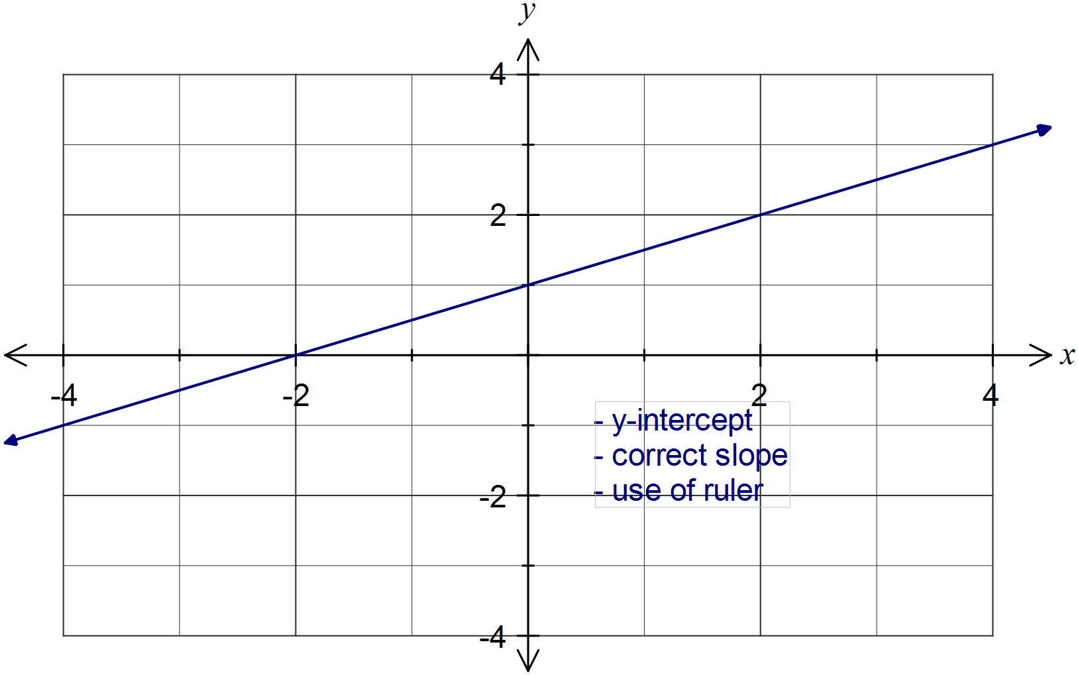

Question 3 (7 marks)

(a) The equation  can be used to represent the statement that during a weekend when a cafe sold 87 muffins, the shop sold 23 more muffins on Saturday than on Sunday.

(i) Explain what the variable x represents. (1 mark)

x is the number of muffins sold on Sunday.

(ii) How many muffins did the shop sell on Saturday? (2 marks)



(b) Solve the following equations.

(i) . (2 marks)



(ii) . (2 marks)



Question 4 (8 marks)

The number of late passes issued daily by a school over a four week period were as follows:

8, 7, 7, 7, 9, 6, 5, 4, 14, 4, 6, 8, 10, 6, 5, 4, 8, 7, 9, 9

(a) Determine the five number summary for this data. (3 marks)

Ordered data: 4, 4, 4, 5, 5, 6, 6, 6, 7, 7, 7, 7, 8, 8, 8, 9, 9, 9, 10, 14.

Min: 4

Max: 14

Med: 7

LQ: 5.5

UQ: 8.5

(b) Is the value of 14 in the above list an outlier for the data set? Justify your answer.

(2 marks)

Yes, using UQ + 1.5 IQR:



(c) Use the five number summary to construct a box plot on the scale below that reflects your response in (b). (3 marks)

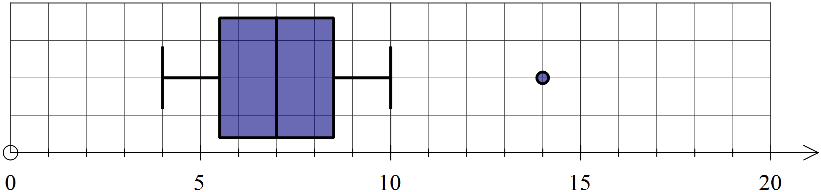

Question 5 (8 marks)

Four matrices are given by .

(a) State the size of the column matrix. (1 mark)

2 by 1

(b) If possible, calculate the following. If not possible, explain why.

(i) . (1 mark)



(ii) . (1 mark)



(iii) . (1 mark)

Not possible to subtract matrices unless they have same dimensions.

(iv) . (1 mark)



(b) If , determine the values of e and f. (3 marks)



Question 6 (8 marks)

(a) Determine the value of  when . (2 marks)



(b) The variables v, u and t are related by the formula . Calculate

(i) v, when . (1 mark)



(ii) u, when . (2 marks)



(iii) t, when . (3 marks)



Question 7 (7 marks)

A courier company charge according to package size and delivery distance, as shown in the table below.

|  |  |  |  |  |
| --- | --- | --- | --- | --- |
| Distance (km) |  |  |  |  |
| Small package | $10 | $20 | $25 | $30 |
| Large package | $20 | $30 | $35 | $40 |

(a) Determine the cost for a business to send the following packages:

(i) One small package to a location 65 km away. (1 mark)

$30

(ii) One large package to a location 10 km away. (1 mark)

$20

(iii) Four small packages to a location 39 km away. (2 marks)



(b) Graph the charges for sending large packages for distances of up to 80 km on the axes below. (3 marks)

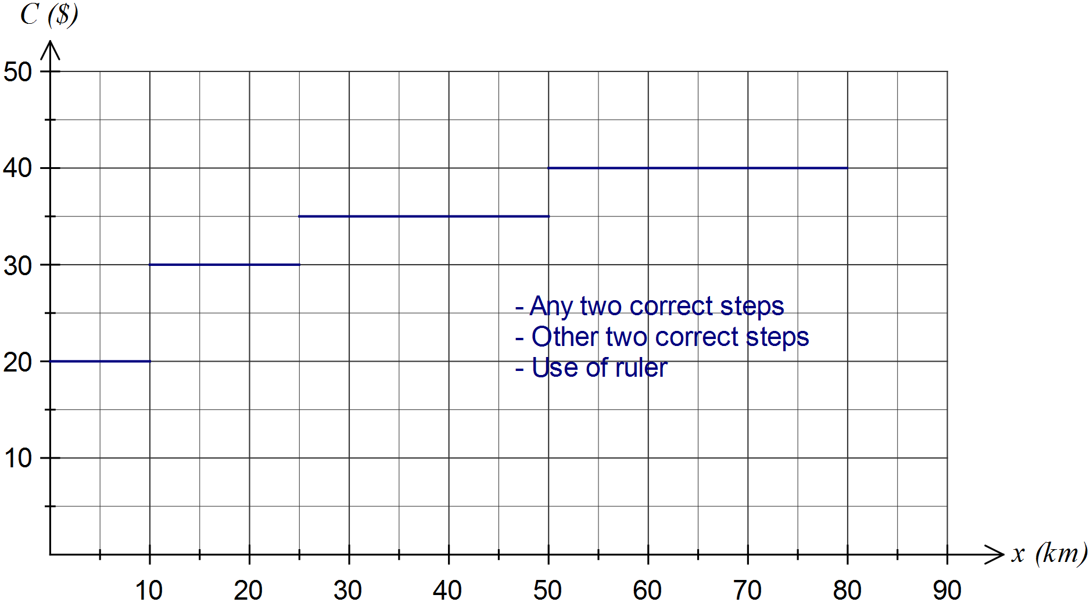

Question 8 (4 marks)

The number of direct paths between buildings A, B and C are shown in the table below.

|  |  |  |  |
| --- | --- | --- | --- |
|  | A | B | C |
| A | 0 | 1 | 1 |
| B | 1 | 0 | 0 |
| C | 1 | 0 | 0 |

(a) Display the number of direct paths between the buildings in a matrix M. (1 mark)



(b) Calculate the square of matrix M, M2. (2 marks)



(c) Explain the meaning of the number in the first row and first column of M2 in the context of route matrices. (1 mark)

There are two two-stage paths to travel from A to A.

Additional working space

Question number: _________

This examination paper may be freely copied, or communicated on an intranet, for non-commercial purposes within educational institutes that have purchased the paper from WA Examination Papers provided that WA Examination Papers is acknowledged as the copyright owner. Teachers within Rossmoyne Senior High School may change the paper provided that WA Examination Paper's moral rights are not infringed.

Copying or communication for any other purposes can only be done within the terms of the Copyright Act or with prior written permission of WA Examination papers.

*Published by WA Examination Papers*

*PO Box 445 Claremont WA 6910*